Accessing Your Teaching Family Homes Email Account
(New Hire)

Below are instructions on to how to access your e-mail on the Internet.

In Internet Explorer (or any other Web Browser):

Type in the address bar: login.microsoftonline.com

- Your username (email address) will be lowercase:

User Name:
Password:

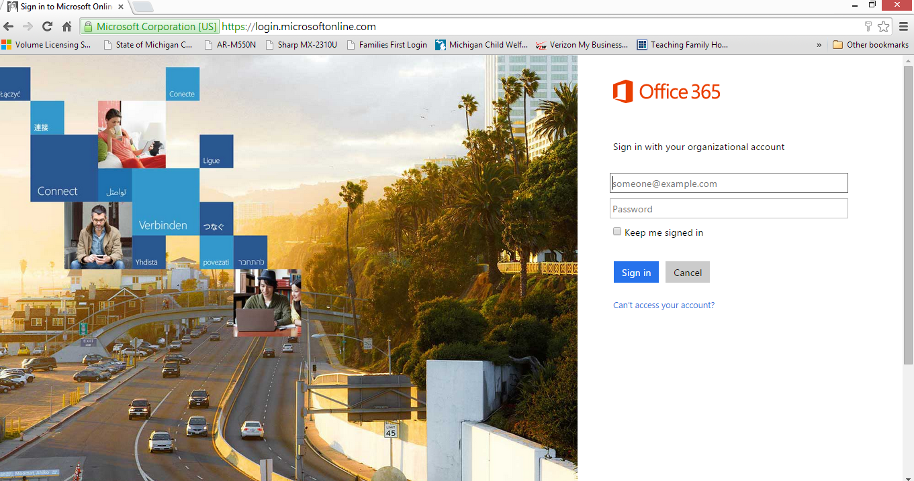

Adding Signature

Keeping in compliance with the USDA we need to make sure everyone has the disclosure at the bottom of their emails.

Copy the following text by selecting the area, right click and select copy.

This document contains confidential information from Teaching Family Homes and is intended solely for the use of the individual(s) names on this e-mail. If you are not the intended recipient, you are notified that disclosing, copying, distributing, or taking action in reliance on the contents of this information is strictly prohibited. If you are not the intended recipient of this e-mail, to prevent future transmissions like this one, please notify me by e-mailing the sender.
This institution is an equal opportunity provider and employer

- Login to Office 365
- In Outlook Web App, click Settings > Options.
- In Options, click Settings > Mail.
- Under Email signature, in the text box, make sure the cursor is in the box, hold down the Ctrl key and V key at the same time this will paste the disclosure in the box.
- Your signature must be displayed at the bottom of all outgoing items, including replies and forwards, check the box Automatically include my signature on messages I send. (located right under the text box). If you don’t select this option, you will have to add the disclosure manually every time you send a message.
- Click Save.
** For those who want their name and other miscellaneous information, type what you would like in the box first, space down then Crtl+V to copy the disclosure.

Smartphones
To add your email to your phone, download the OWA (Outlook Web App) and sign in.

Also, you have access to Agency forms by using our website (www.teachingfamilyhomes.com). Click on the Staff Resources tab at the top of the page. When prompted, the password is: Fall14

