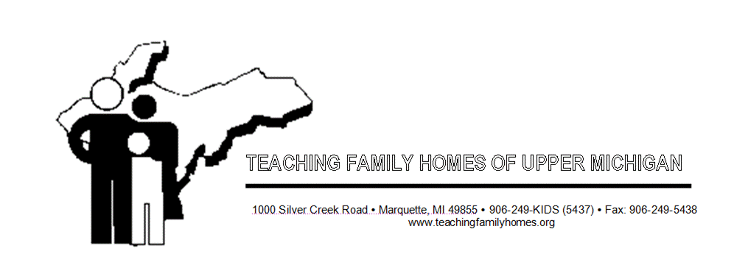

Teaching-Family Homes of Upper Michigan

DENTAL/PHYSICAL EXAMINATION UPDATE
(Only used if dental/physical exceeds timeframes.)

Youth Name:

Program:

The youth’s dental / physical examination, originally scheduled for
(date)

was missed due to .
(reason appointment missed)

On , a dental / physical examination was

scheduled / re-scheduled. The earliest possible date is with
(name of Doctor)

and will occur on .
(date of appt.)

Supervisor Signature Date

/tmp/in/input.doc

